Name _____________________________ US Map #4
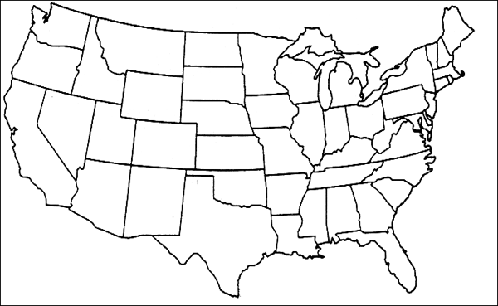

#1-31 are the states we have already learned. You will be tested on all 41 states on SS Map Quiz #4. Spelling will count on all 41 states.
Number the states yourself and then practice to see if you know them. Remember, spelling counts.
- _____________________________ 17. _____________________________ 32. _______________________________
- _____________________________ 18. _____________________________ 33. _______________________________
- _____________________________ 19. _____________________________ 34. _______________________________
- _____________________________ 20. _____________________________ 35. _______________________________
- _____________________________ 21. _____________________________ 36. _______________________________
- _____________________________ 22. _____________________________ 37. _______________________________
- _____________________________ 23. _____________________________ 38. _______________________________
- _____________________________ 24. _____________________________ 39. _______________________________
- _____________________________ 25. _____________________________ 40. _______________________________
- _____________________________ 26. _____________________________ 41. _______________________________
- _____________________________ 27. _____________________________
- _____________________________ 28. _____________________________
- _____________________________ 29. _____________________________
- _____________________________ 30. _____________________________
- _____________________________ 31. _____________________________
- _____________________________

